US Births (2018) Data Analysis

STAT 448 Final Project

Ankit Datta - Group 7

**Introduction:**

The [dataset](https://www.kaggle.com/des137/us-births-2018) (<https://www.kaggle.com/des137/us-births-2018>) we investigated was the data containing information about births in the United States in 2018. US Births is a CDC maintained dataset populated with 55 variables and 3,801,534 observations. Columns in the dataset have information about the newborn’s parents, place and time of birth, birth circumstances, biographical information, etc. The [CDC user guide](http://ftp.cdc.gov/pub/Health_Statistics/NCHS/Dataset_Documentation/DVS/natality/UserGuide2018-508.pdf) provides detailed information about what the variables mean and their coded values if they are a factor variable. For example, many variables such as RACE, EDUCATION, etc. have a coded value and a value of 9 represents missing or unknown information.

Based on this dataset, **the goal and question** I wanted to answer was whether we could **predict the odds of a cesarean birth based on any combination of a subset of these predictors**. In order to do so, the dataset must be cleaned and validated to remove any observations with NA or missing values for any predictor.

Looking at the initial dataset, we see variables such as DMAR, IMP_SEX, MAGE_IMPFLG, MAR_IMP, and more containing a very large number of NA’s. We can also see that the max for all the variables is either 9, 99, 999, or 9999. In order to build a logistic regression model, we must remove all observations with an NA or a value which represents a missing variable since those observations will not help us build a model.

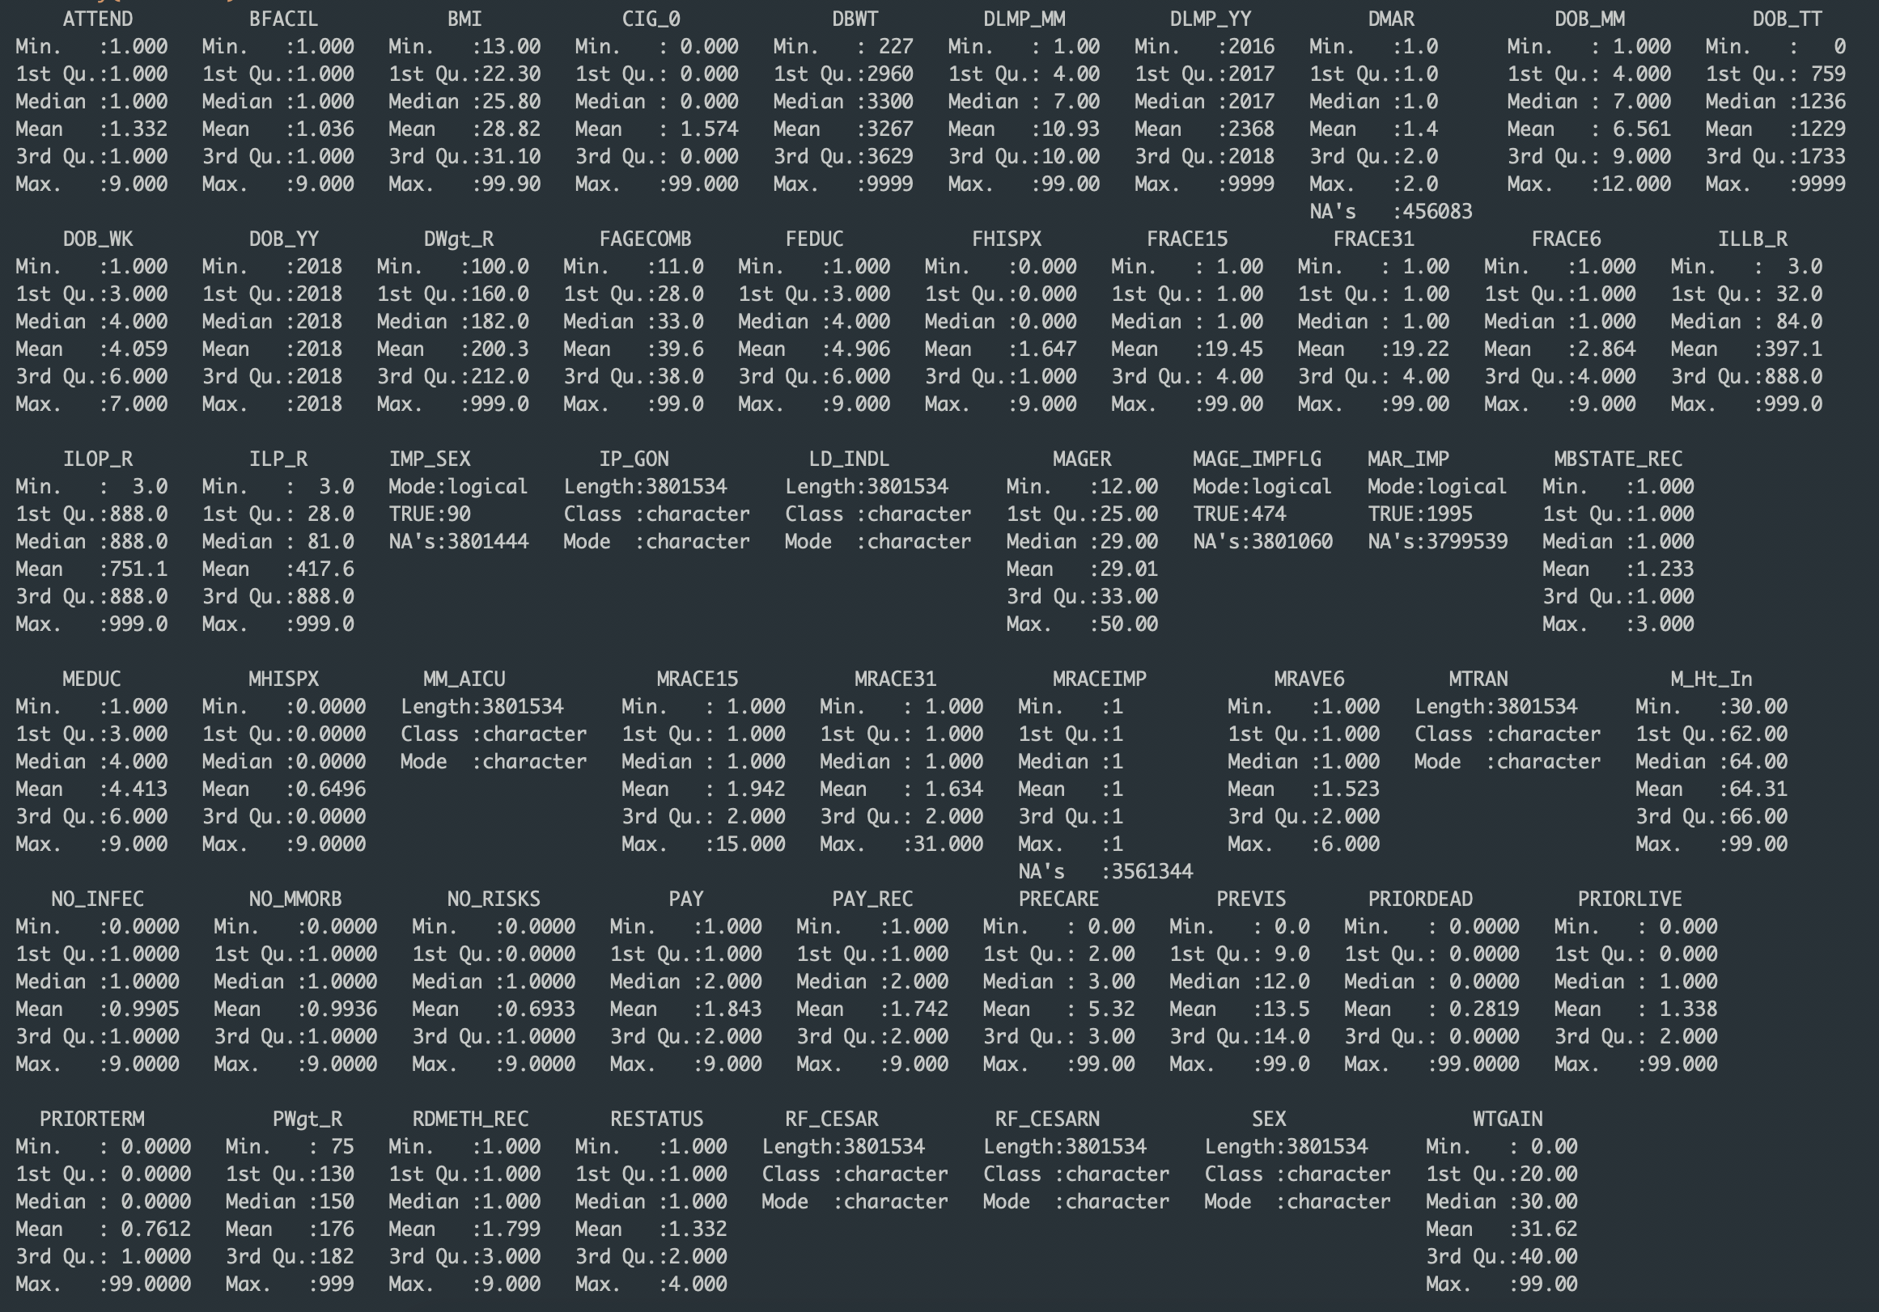

In order to answer this question, we need to determine which subset of predictors are of interest and then determine how cesarean births are represented in our dataset. Due to the fact that there are over 3 million observations, we cannot construct plots due to lack of computational power so we must look at the relevant statistics in order to make conclusions.

Doing some preliminary analysis, we can see that we have Boolean, character, and numeric variables that we all represent coding according to the CDC user guide which will need to be translated to categorical variables to set up for our analysis later.

We would also like to focus our analysis on the most relevant predictors such as MRACE6+FRACE6 (races of parents), FEDUC+MEDUC (education level of parents), DOB_MM, DOB_TT, DOB_WK (month, time, and day of the week of birth), NO_RISKS (risk factors during pregnancy), PRECARE/PREVIS (prenatal care and visits), PRIORDEAD/PRIORLIVE/PRIORTERM (past history of births and terminated pregnancies of mother), and finally RDMETH_REC (method of delivery).

**Methods:**

I use R initially to subset, validate, verify, and make initial observations about our dataset.

We must first determine which births in our dataset are cesarean births. In order to do so, we must look at the RDMETH_REC variable.

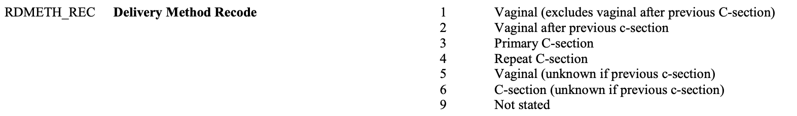

As is shown, the values 3, 4, and 6 are coded for C-sections. Thus, we first create a new column in our dataset CSECTION which will be a binary variable representing whether a birth was a cesarean birth. If the observation has value 3, 4, or 6 then CSECTION = 1 else CSECTION = 0. By doing this, we are setting up a Bernoulli distribution representing having a C-section or not that can be used in our logistic regression to predict the odds. We can also not include the RDMETH_REC variable in our subset as we have already extracted the relevant information.

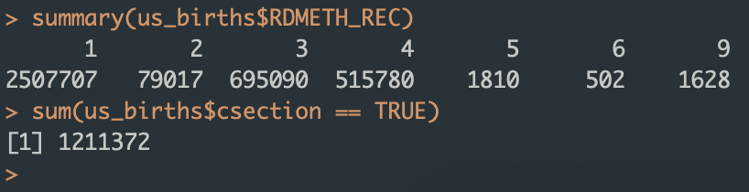

Clearly, 695090+515780+502 = 1,211,372 so CSECTION is valid. Initially, this shows us that around 1,211,372/3,801,534 = 31.9% of births in 2018 were C-section births.

Next, we choose our initial subset of relevant variables that can be used in our logistic regression model. By looking at the variables and what they represent, we decide to keep the following 25 variables and CSECTION:

* + Child Info: DBWT (birth weight), MONTH (month born), TIME (time of day), DAY (day of week), and SEX
  + Parental Info: MAR (marital status), FAGE (father age), FEDUC (father education), FRACE (father race), MAGE, MEDUC, MRACE, ICU (admitted to ICU), M_HT_IN (mother height), PREWEIGHT (pre-pregnancy weight), WTGAIN (weight gain), BMI, CIG_0 (daily cigarettes before birth)
  + Birth Info: NO_RISKS (no risk factors), PRECARE (time when prenatal care started), PREVIS (number of pretanal visits), PRIORDEAD (prior births deceased), PRIORLIVE (prior births living), PRIORTERM (prior pregnancy terminations), CESAR_PREV (number of previous C-sections)

We only include the 26/55 variables since other variables in our original dataset contained irrelevant information or redundant information such as BFACIL, 3 coded variables represented FRACE and MRACE, IP_GON – if gonorrhea was present during pregnancy, etc. The variables that were the remaining columns that could be used to predict the odds of having a cesarean birth. We parse the data frame and convert all necessary columns as factors and convert binary character variables to integers so that SAS can interpret them as class variables and have levels to the factor variable.

Finally, we must validate our observations and remove any observations with any NA’s or any values that represent unknown/missing (9, 99, 999 etc. depending on the variable according the key). Doing so, we get our final birth dataset with 2,521,050 observations, 25 predictor variables, and our binary response variable CSECTION which we will use moving forward.

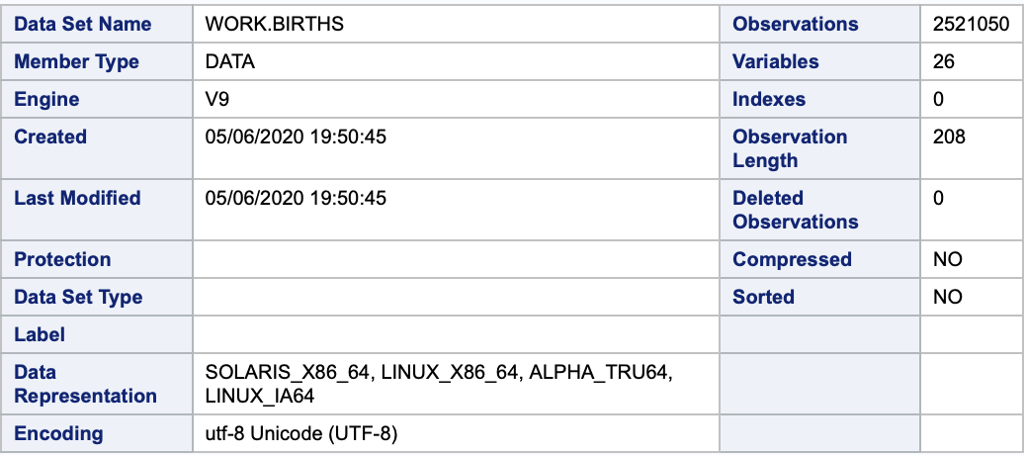

In our final births dataset, there are 808,802 cesarean births which means about 32.1% of that dataset had C-section births.

Now that we have our dataset and CSECTION variable, we can proceed with our logistic regression in SAS. We know that our goal is to predict the odds of having a cesarean birth, and also that CSECTION is a binary variable with value 0 if not a C-section and 1 if it was a C-section. Then we can use logistic regression to set up a model of the form CSECTION = [subset of predictors].

In order to choose our predictors, we must use forward, backward, and stepwise selection to see which method leads to the best-fitting and most significant model. For all of these PROC LOGISTIC steps, we specify our class variables: CSECTION, MAR, MONTH, DAY, FEDUC, FRACE, MEDUC, ICU, MRACE, NO_RISKS, SEX with param=ref ref=first;

We will get summaries of our variable selection, as well as relevant null hypothesis testing, odds ratios, and goodness of fit tests for each of the methods that we can use to determine which best fits our data. Then we can use that model to make conclusions about our original questions of predicting the odds of having a C-section. Since there are over 2.5 million observations, the model is extremely over-determined and plotting is not possible but the full dataset is used instead of randomly sampling chunks.

**Results:**

We get the results of forward, backward, and stepwise selection shown in Appendix A. This shows the summaries of each of the methods as well as model fit statistics and global hypothesis tests. All methods lead to the same model which is shown below. First, we look at the model statistics:

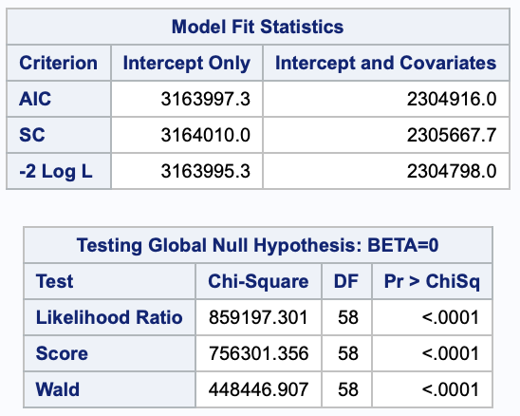

The model with the variables has a significantly lower AIC and SC, so therefore that model is better. From the global null hypothesis, we see that the p-values are <0.0001 so we reject the null that all betas are 0 and conclude that at least one of the predictors is not equal to 0. Then we look at the Type 3 analysis of variables and see that all the predictors are significant with p-values <0.05 therefore, the betas for all the predictors are not equal to 0.

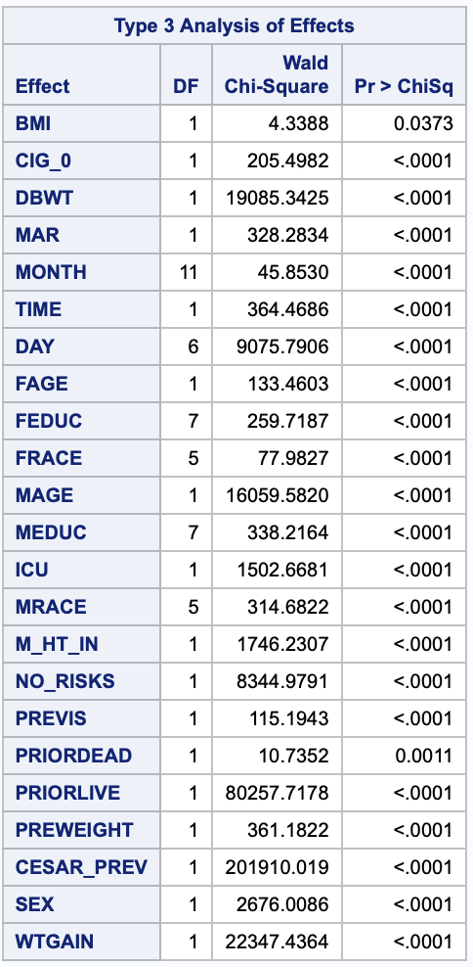

We test the Goodness-of-Fit for this model next:

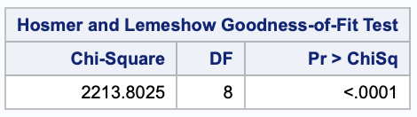

We that the p-value is <0.0001 which means that we reject the null the model does not fit our data, but with over 2 million observations, this was to be expected and with all 3 selection methods selecting the same model, we can say that the final model predicting the odds of having a cesarean birth as a function of the 23 predictors from before. Starting with 55 variables, this model eliminates 22 other variables that are not included in the model. The influence plots could not be generated for 2 million data points and using the PLOTS(MAXPOINTS=NONE) option for PROC LOGISTIC in SAS causes a segmentation violation. The predictors were all significant in the model and although we reject the goodness of fit, we proceed with the model and make conclusions.

We can try to answer the question and our goal to predict the odds that a birth will be a C-section based on some subset of predictors from our original dataset. Using the 23 predictors, we can apply the statistics to the real world that the data represents.

**Conclusions:**

We can examine the odds ratios in order to make conclusions to real-world applications of the question we are trying to answer: can we predict the odds of having a cesarean birth based on 23 predictors? First we look at the most significant predictors:

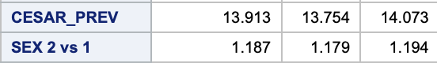







Highest Predictor - CESAR_PREV: for every additional previous cesarean section a woman has had, the odds of the current pregnancy being a cesarean birth is 13.9 times more likely. This is predictable, as having a previous C-section is the most obvious predictor for if the birth is going to be a C-section. Another predictor with high odds is being admitted to the ICU (2) during delivery leads to the odds of the C-section to be 5.5 times more than not being admitted (1).

Lowest Odds - PRIORLIVE: for every additional live birth a woman has had in the past, the odds of this birth being a C-section are .581 times as high. This is showing that the more children a women has had, the odds of the current birth being a C-section are lowered by 42%. Similarly, odds of having a cesarean birth are 0.682 times lower for women with no risks (1) during pregnancy compared to risk experienced (0), since having no risks would mean a healthy pregnancy and no complications occurred during pregnancy so it is more likely to be a non cesarean birth.

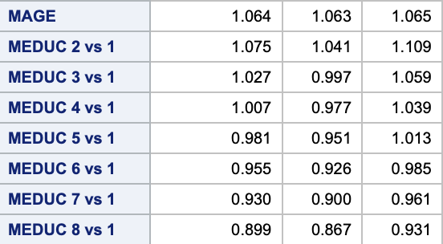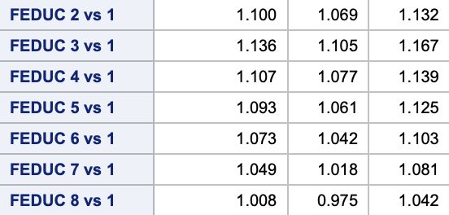

Education level of Bachelor’s Degree and above (6-8) are only significant for mothers with odds of cesarean births compared to 8th grade or less (1) education being between 5-10% lower with lower odds for higher level of education. The odds for higher education levels is also much lower compared to the odds of high-school degree meaning more educated women have less likely odds to have a cesarean birth.

Father’s education shows that odds of having a C-section are highest for High School/GED (3) level compared to (1) which cannot be explained but increasing education levels after 3 along with odds close to 1 for (6) – (8) meaning and not significant. This means that there is no real difference in the odds of having a C-section based on the father’s education beyond a bachelor’s degree.

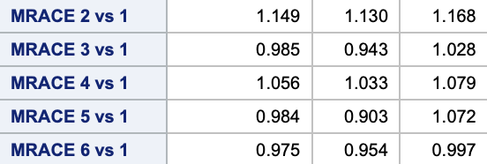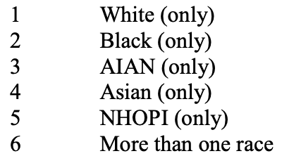

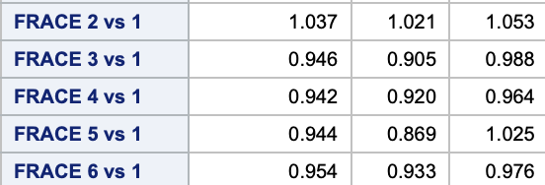

Odds of black mothers having a C-section compared to white mothers is 14.9% higher, and black mother’s have highest odds overall. Race plays small role in determining odds of having a C-section compared to other factors, most odds ratios are insignificant or affect the odds of having a C-section by 2% compared to each other.

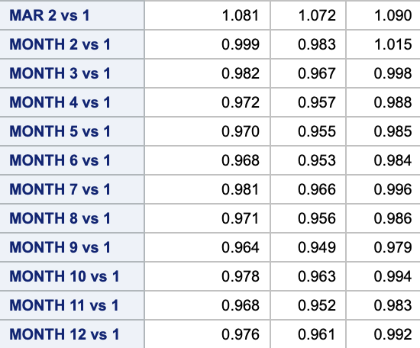

Marital Status 2 v 1 - The odds of having a cesarean birth for unmarried women (2) are 8.1% more than married women (1). So being married decreases the odds of having a C-section.



Having a baby in January or February has the highest odds of being a C-section, with every month having between 2-3% lower odds of having a C-section and odds in February not being significant compared to January. This means that babies born in the first two months of the year have the highest odds of being a cesarean birth, and being born in September has the lowest odds.

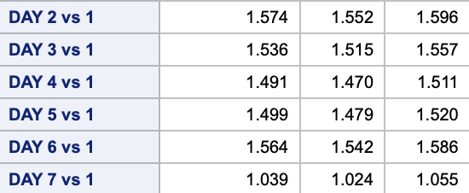

Odds are lowest for Sunday (1) births, every week day (2-6) has around 1.5 times higher odds of having a cesarean birth and Saturdays (7) have 3.9% more. This shows that the odds of a birth on a weekend being a cesarean birth are the lowest, and births during the week have the highest odds.

So all of these predictors overall affect the odds of having a cesarean birth by a percentage but within the levels of predictors, there may not be a difference in the odds. The predictor that will most influence the odds is number of previous C-sections which multiplies the odds by 13.9 for each additional one, and the predictor that most lowers the odds is number of prior births which multiples the odds by 0.581 for every additional previous birth.

**Appendix:**

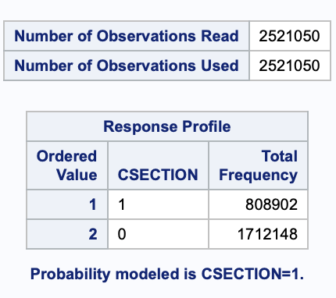

Classification table for class variables:

| **Class Level Information** | | | | | | | | | | | | |
| --- | --- | --- | --- | --- | --- | --- | --- | --- | --- | --- | --- | --- |
| **Class** | **Value** | **Design Variables** | | | | | | | | | | |
| **MAR** | **1** | 0 |  |  |  |  |  |  |  |  |  |  |
|  | **2** | 1 |  |  |  |  |  |  |  |  |  |  |
|  |  |  |  |  |  |  |  |  |  |  |  |  |
| **MONTH** | **1** | 0 | 0 | 0 | 0 | 0 | 0 | 0 | 0 | 0 | 0 | 0 |
|  | **2** | 1 | 0 | 0 | 0 | 0 | 0 | 0 | 0 | 0 | 0 | 0 |
|  | **3** | 0 | 1 | 0 | 0 | 0 | 0 | 0 | 0 | 0 | 0 | 0 |
|  | **4** | 0 | 0 | 1 | 0 | 0 | 0 | 0 | 0 | 0 | 0 | 0 |
|  | **5** | 0 | 0 | 0 | 1 | 0 | 0 | 0 | 0 | 0 | 0 | 0 |
|  | **6** | 0 | 0 | 0 | 0 | 1 | 0 | 0 | 0 | 0 | 0 | 0 |
|  | **7** | 0 | 0 | 0 | 0 | 0 | 1 | 0 | 0 | 0 | 0 | 0 |
|  | **8** | 0 | 0 | 0 | 0 | 0 | 0 | 1 | 0 | 0 | 0 | 0 |
|  | **9** | 0 | 0 | 0 | 0 | 0 | 0 | 0 | 1 | 0 | 0 | 0 |
|  | **10** | 0 | 0 | 0 | 0 | 0 | 0 | 0 | 0 | 1 | 0 | 0 |
|  | **11** | 0 | 0 | 0 | 0 | 0 | 0 | 0 | 0 | 0 | 1 | 0 |
|  | **12** | 0 | 0 | 0 | 0 | 0 | 0 | 0 | 0 | 0 | 0 | 1 |
|  |  |  |  |  |  |  |  |  |  |  |  |  |
| **DAY** | **1** | 0 | 0 | 0 | 0 | 0 | 0 |  |  |  |  |  |
|  | **2** | 1 | 0 | 0 | 0 | 0 | 0 |  |  |  |  |  |
|  | **3** | 0 | 1 | 0 | 0 | 0 | 0 |  |  |  |  |  |
|  | **4** | 0 | 0 | 1 | 0 | 0 | 0 |  |  |  |  |  |
|  | **5** | 0 | 0 | 0 | 1 | 0 | 0 |  |  |  |  |  |
|  | **6** | 0 | 0 | 0 | 0 | 1 | 0 |  |  |  |  |  |
|  | **7** | 0 | 0 | 0 | 0 | 0 | 1 |  |  |  |  |  |
|  |  |  |  |  |  |  |  |  |  |  |  |  |
| **FEDUC** | **1** | 0 | 0 | 0 | 0 | 0 | 0 | 0 |  |  |  |  |
|  | **2** | 1 | 0 | 0 | 0 | 0 | 0 | 0 |  |  |  |  |
|  | **3** | 0 | 1 | 0 | 0 | 0 | 0 | 0 |  |  |  |  |
|  | **4** | 0 | 0 | 1 | 0 | 0 | 0 | 0 |  |  |  |  |
|  | **5** | 0 | 0 | 0 | 1 | 0 | 0 | 0 |  |  |  |  |
|  | **6** | 0 | 0 | 0 | 0 | 1 | 0 | 0 |  |  |  |  |
|  | **7** | 0 | 0 | 0 | 0 | 0 | 1 | 0 |  |  |  |  |
|  | **8** | 0 | 0 | 0 | 0 | 0 | 0 | 1 |  |  |  |  |
|  |  |  |  |  |  |  |  |  |  |  |  |  |
| **FRACE** | **1** | 0 | 0 | 0 | 0 | 0 |  |  |  |  |  |  |
|  | **2** | 1 | 0 | 0 | 0 | 0 |  |  |  |  |  |  |
|  | **3** | 0 | 1 | 0 | 0 | 0 |  |  |  |  |  |  |
|  | **4** | 0 | 0 | 1 | 0 | 0 |  |  |  |  |  |  |
|  | **5** | 0 | 0 | 0 | 1 | 0 |  |  |  |  |  |  |
|  | **6** | 0 | 0 | 0 | 0 | 1 |  |  |  |  |  |  |
|  |  |  |  |  |  |  |  |  |  |  |  |  |
| **MEDUC** | **1** | 0 | 0 | 0 | 0 | 0 | 0 | 0 |  |  |  |  |
|  | **2** | 1 | 0 | 0 | 0 | 0 | 0 | 0 |  |  |  |  |
|  | **3** | 0 | 1 | 0 | 0 | 0 | 0 | 0 |  |  |  |  |
|  | **4** | 0 | 0 | 1 | 0 | 0 | 0 | 0 |  |  |  |  |
|  | **5** | 0 | 0 | 0 | 1 | 0 | 0 | 0 |  |  |  |  |
|  | **6** | 0 | 0 | 0 | 0 | 1 | 0 | 0 |  |  |  |  |
|  | **7** | 0 | 0 | 0 | 0 | 0 | 1 | 0 |  |  |  |  |
|  | **8** | 0 | 0 | 0 | 0 | 0 | 0 | 1 |  |  |  |  |
|  |  |  |  |  |  |  |  |  |  |  |  |  |
| **ICU** | **1** | 0 |  |  |  |  |  |  |  |  |  |  |
|  | **2** | 1 |  |  |  |  |  |  |  |  |  |  |
|  |  |  |  |  |  |  |  |  |  |  |  |  |
| **MRACE** | **1** | 0 | 0 | 0 | 0 | 0 |  |  |  |  |  |  |
|  | **2** | 1 | 0 | 0 | 0 | 0 |  |  |  |  |  |  |
|  | **3** | 0 | 1 | 0 | 0 | 0 |  |  |  |  |  |  |
|  | **4** | 0 | 0 | 1 | 0 | 0 |  |  |  |  |  |  |
|  | **5** | 0 | 0 | 0 | 1 | 0 |  |  |  |  |  |  |
|  | **6** | 0 | 0 | 0 | 0 | 1 |  |  |  |  |  |  |
|  |  |  |  |  |  |  |  |  |  |  |  |  |
| **NO_RISKS** | **0** | 0 |  |  |  |  |  |  |  |  |  |  |
|  | **1** | 1 |  |  |  |  |  |  |  |  |  |  |
|  |  |  |  |  |  |  |  |  |  |  |  |  |
| **SEX** | **1** | 0 |  |  |  |  |  |  |  |  |  |  |
|  | **2** | 1 |  |  |  |  |  |  |  |  |  |  |

Backward Selection:

| **Summary of Backward Elimination** | | | | | |
| --- | --- | --- | --- | --- | --- |
| **Step** | **Effect Removed** | **DF** | **Number In** | **Wald Chi-Square** | **Pr > ChiSq** |
| **1** | **PRIORTERM** | 1 | 24 | 1.6743 | 0.1957 |
| **2** | **PRECARE** | 1 | 23 | 2.9706 | 0.0848 |

| **Model Fit Statistics** | | |
| --- | --- | --- |
| **Criterion** | **Intercept Only** | **Intercept and Covariates** |
| **AIC** | 3163997.3 | 2304916.0 |
| **SC** | 3164010.0 | 2305667.7 |
| **-2 Log L** | 3163995.3 | 2304798.0 |

| **Testing Global Null Hypothesis: BETA=0** | | | |
| --- | --- | --- | --- |
| **Test** | **Chi-Square** | **DF** | **Pr > ChiSq** |
| **Likelihood Ratio** | 859197.301 | 58 | <.0001 |
| **Score** | 756301.356 | 58 | <.0001 |
| **Wald** | 448446.907 | 58 | <.0001 |

Forward Selection:

| **Summary of Forward Selection** | | | | | |
| --- | --- | --- | --- | --- | --- |
| **Step** | **Effect Entered** | **DF** | **Number In** | **Score Chi-Square** | **Pr > ChiSq** |
| **1** | **CESAR_PREV** | 1 | 1 | 539134.702 | <.0001 |
| **2** | **PRIORLIVE** | 1 | 2 | 68210.3286 | <.0001 |
| **3** | **BMI** | 1 | 3 | 51276.5468 | <.0001 |
| **4** | **MAGE** | 1 | 4 | 33254.1795 | <.0001 |
| **5** | **DBWT** | 1 | 5 | 22110.7786 | <.0001 |
| **6** | **WTGAIN** | 1 | 6 | 23052.9311 | <.0001 |
| **7** | **M_HT_IN** | 1 | 7 | 9204.2087 | <.0001 |
| **8** | **DAY** | 6 | 8 | 9069.8402 | <.0001 |
| **9** | **NO_RISKS** | 1 | 9 | 8699.2572 | <.0001 |
| **10** | **SEX** | 1 | 10 | 2735.7951 | <.0001 |
| **11** | **MRACE** | 5 | 11 | 1856.6319 | <.0001 |
| **12** | **ICU** | 1 | 12 | 1708.4676 | <.0001 |
| **13** | **MEDUC** | 7 | 13 | 1394.8401 | <.0001 |
| **14** | **MAR** | 1 | 14 | 488.4440 | <.0001 |
| **15** | **PREWEIGHT** | 1 | 15 | 381.6632 | <.0001 |
| **16** | **TIME** | 1 | 16 | 360.5597 | <.0001 |
| **17** | **FEDUC** | 7 | 17 | 273.8192 | <.0001 |
| **18** | **CIG_0** | 1 | 18 | 213.4121 | <.0001 |
| **19** | **FAGE** | 1 | 19 | 133.9560 | <.0001 |
| **20** | **PREVIS** | 1 | 20 | 113.4147 | <.0001 |
| **21** | **FRACE** | 5 | 21 | 77.8381 | <.0001 |
| **22** | **MONTH** | 11 | 22 | 45.8274 | <.0001 |
| **23** | **PRIORDEAD** | 1 | 23 | 10.7389 | 0.0010 |

| **Model Fit Statistics** | | |
| --- | --- | --- |
| **Criterion** | **Intercept Only** | **Intercept and Covariates** |
| **AIC** | 3163997.3 | 2304916.0 |
| **SC** | 3164010.0 | 2305667.7 |
| **-2 Log L** | 3163995.3 | 2304798.0 |

| **Testing Global Null Hypothesis: BETA=0** | | | |
| --- | --- | --- | --- |
| **Test** | **Chi-Square** | **DF** | **Pr > ChiSq** |
| **Likelihood Ratio** | 859197.301 | 58 | <.0001 |
| **Score** | 756301.356 | 58 | <.0001 |
| **Wald** | 448446.907 | 58 | <.0001 |

Stepwise Selection:

| **Summary of Stepwise Selection** | | | | | | | |
| --- | --- | --- | --- | --- | --- | --- | --- |
| **Step** | **Effect** | | **DF** | **Number In** | **Score Chi-Square** | **Wald Chi-Square** | **Pr > ChiSq** |
| **Entered** | **Removed** |
| **1** | **CESAR_PREV** |  | 1 | 1 | 539134.702 |  | <.0001 |
| **2** | **PRIORLIVE** |  | 1 | 2 | 68210.3286 |  | <.0001 |
| **3** | **BMI** |  | 1 | 3 | 51276.5468 |  | <.0001 |
| **4** | **MAGE** |  | 1 | 4 | 33254.1795 |  | <.0001 |
| **5** | **DBWT** |  | 1 | 5 | 22110.7786 |  | <.0001 |
| **6** | **WTGAIN** |  | 1 | 6 | 23052.9311 |  | <.0001 |
| **7** | **M_HT_IN** |  | 1 | 7 | 9204.2087 |  | <.0001 |
| **8** | **DAY** |  | 6 | 8 | 9069.8402 |  | <.0001 |
| **9** | **NO_RISKS** |  | 1 | 9 | 8699.2572 |  | <.0001 |
| **10** | **SEX** |  | 1 | 10 | 2735.7951 |  | <.0001 |
| **11** | **MRACE** |  | 5 | 11 | 1856.6319 |  | <.0001 |
| **12** | **ICU** |  | 1 | 12 | 1708.4676 |  | <.0001 |
| **13** | **MEDUC** |  | 7 | 13 | 1394.8401 |  | <.0001 |
| **14** | **MAR** |  | 1 | 14 | 488.4440 |  | <.0001 |
| **15** | **PREWEIGHT** |  | 1 | 15 | 381.6632 |  | <.0001 |
| **16** |  | **BMI** | 1 | 14 |  | 3.1716 | 0.0749 |
| **17** | **TIME** |  | 1 | 15 | 360.5623 |  | <.0001 |
| **18** | **FEDUC** |  | 7 | 16 | 272.8844 |  | <.0001 |
| **19** | **CIG_0** |  | 1 | 17 | 213.0555 |  | <.0001 |
| **20** | **FAGE** |  | 1 | 18 | 134.0967 |  | <.0001 |
| **21** | **PREVIS** |  | 1 | 19 | 113.4549 |  | <.0001 |
| **22** | **FRACE** |  | 5 | 20 | 77.8242 |  | <.0001 |
| **23** | **MONTH** |  | 11 | 21 | 45.7961 |  | <.0001 |
| **24** | **PRIORDEAD** |  | 1 | 22 | 10.7204 |  | 0.0011 |
| **25** | **BMI** |  | 1 | 23 | 4.3403 |  | 0.0372 |

Analysis of Max Likelihood Estimates:

| **Analysis of Maximum Likelihood Estimates** | | | | | | |
| --- | --- | --- | --- | --- | --- | --- |
| **Parameter** |  | **DF** | **Estimate** | **Standard Error** | **Wald Chi-Square** | **Pr > ChiSq** |
| **Intercept** |  | 1 | 2.8909 | 0.1601 | 326.1356 | <.0001 |
| **BMI** |  | 1 | 0.00580 | 0.00278 | 4.3388 | 0.0373 |
| **CIG_0** |  | 1 | 0.00530 | 0.000370 | 205.4982 | <.0001 |
| **DBWT** |  | 1 | -0.00041 | 2.987E-6 | 19085.3425 | <.0001 |
| **MAR** | **2** | 1 | 0.0775 | 0.00428 | 328.2834 | <.0001 |
| **MONTH** | **2** | 1 | -0.00141 | 0.00828 | 0.0290 | 0.8648 |
| **MONTH** | **3** | 1 | -0.0180 | 0.00805 | 4.9987 | 0.0254 |
| **MONTH** | **4** | 1 | -0.0281 | 0.00816 | 11.8497 | 0.0006 |
| **MONTH** | **5** | 1 | -0.0305 | 0.00801 | 14.5193 | 0.0001 |
| **MONTH** | **6** | 1 | -0.0323 | 0.00807 | 15.9752 | <.0001 |
| **MONTH** | **7** | 1 | -0.0194 | 0.00799 | 5.8919 | 0.0152 |
| **MONTH** | **8** | 1 | -0.0295 | 0.00790 | 13.9981 | 0.0002 |
| **MONTH** | **9** | 1 | -0.0367 | 0.00805 | 20.7517 | <.0001 |
| **MONTH** | **10** | 1 | -0.0218 | 0.00798 | 7.4581 | 0.0063 |
| **MONTH** | **11** | 1 | -0.0329 | 0.00812 | 16.4493 | <.0001 |
| **MONTH** | **12** | 1 | -0.0243 | 0.00813 | 8.9566 | 0.0028 |
| **TIME** |  | 1 | -0.00005 | 2.59E-6 | 364.4686 | <.0001 |
| **DAY** | **2** | 1 | 0.4535 | 0.00711 | 4070.7280 | <.0001 |
| **DAY** | **3** | 1 | 0.4292 | 0.00702 | 3735.4029 | <.0001 |
| **DAY** | **4** | 1 | 0.3992 | 0.00704 | 3218.6637 | <.0001 |
| **DAY** | **5** | 1 | 0.4051 | 0.00702 | 3327.7332 | <.0001 |
| **DAY** | **6** | 1 | 0.4472 | 0.00704 | 4034.4496 | <.0001 |
| **DAY** | **7** | 1 | 0.0387 | 0.00778 | 24.7254 | <.0001 |
| **FAGE** |  | 1 | 0.00425 | 0.000368 | 133.4603 | <.0001 |
| **FEDUC** | **2** | 1 | 0.0958 | 0.0146 | 43.1282 | <.0001 |
| **FEDUC** | **3** | 1 | 0.1274 | 0.0139 | 83.9268 | <.0001 |
| **FEDUC** | **4** | 1 | 0.1020 | 0.0143 | 51.2512 | <.0001 |
| **FEDUC** | **5** | 1 | 0.0885 | 0.0150 | 34.7974 | <.0001 |
| **FEDUC** | **6** | 1 | 0.0700 | 0.0145 | 23.3229 | <.0001 |
| **FEDUC** | **7** | 1 | 0.0481 | 0.0153 | 9.8433 | 0.0017 |
| **FEDUC** | **8** | 1 | 0.00779 | 0.0169 | 0.2124 | 0.6449 |
| **FRACE** | **2** | 1 | 0.0362 | 0.00810 | 19.9994 | <.0001 |
| **FRACE** | **3** | 1 | -0.0560 | 0.0224 | 6.2299 | 0.0126 |
| **FRACE** | **4** | 1 | -0.0600 | 0.0118 | 25.9522 | <.0001 |
| **FRACE** | **5** | 1 | -0.0580 | 0.0422 | 1.8862 | 0.1696 |
| **FRACE** | **6** | 1 | -0.0471 | 0.0114 | 16.9347 | <.0001 |
| **MAGE** |  | 1 | 0.0622 | 0.000491 | 16059.5820 | <.0001 |
| **MEDUC** | **2** | 1 | 0.0719 | 0.0162 | 19.6377 | <.0001 |
| **MEDUC** | **3** | 1 | 0.0270 | 0.0155 | 3.0328 | 0.0816 |
| **MEDUC** | **4** | 1 | 0.00725 | 0.0157 | 0.2120 | 0.6452 |
| **MEDUC** | **5** | 1 | -0.0187 | 0.0163 | 1.3160 | 0.2513 |
| **MEDUC** | **6** | 1 | -0.0460 | 0.0160 | 8.3086 | 0.0039 |
| **MEDUC** | **7** | 1 | -0.0726 | 0.0165 | 19.3497 | <.0001 |
| **MEDUC** | **8** | 1 | -0.1070 | 0.0184 | 33.8944 | <.0001 |
| **ICU** | **2** | 1 | 1.7064 | 0.0440 | 1502.6681 | <.0001 |
| **MRACE** | **2** | 1 | 0.1391 | 0.00849 | 268.5994 | <.0001 |
| **MRACE** | **3** | 1 | -0.0154 | 0.0222 | 0.4816 | 0.4877 |
| **MRACE** | **4** | 1 | 0.0543 | 0.0113 | 23.2710 | <.0001 |
| **MRACE** | **5** | 1 | -0.0159 | 0.0438 | 0.1321 | 0.7163 |
| **MRACE** | **6** | 1 | -0.0249 | 0.0113 | 4.8459 | 0.0277 |
| **M_HT_IN** |  | 1 | -0.1037 | 0.00248 | 1746.2307 | <.0001 |
| **NO_RISKS** | **1** | 1 | -0.3826 | 0.00419 | 8344.9791 | <.0001 |
| **PREVIS** |  | 1 | 0.00456 | 0.000425 | 115.1943 | <.0001 |
| **PRIORDEAD** |  | 1 | -0.0340 | 0.0104 | 10.7352 | 0.0011 |
| **PRIORLIVE** |  | 1 | -0.5428 | 0.00192 | 80257.7178 | <.0001 |
| **PREWEIGHT** |  | 1 | 0.00894 | 0.000471 | 361.1822 | <.0001 |
| **CESAR_PREV** |  | 1 | 2.6328 | 0.00586 | 201910.019 | <.0001 |
| **SEX** | **2** | 1 | 0.1712 | 0.00331 | 2676.0086 | <.0001 |
| **WTGAIN** |  | 1 | 0.0173 | 0.000116 | 22347.4364 | <.0001 |